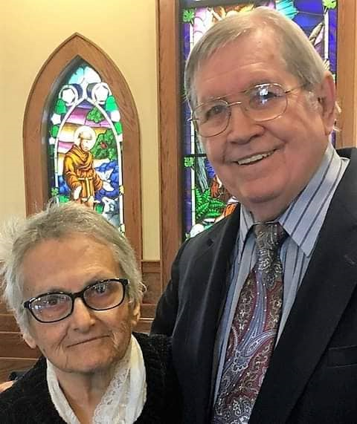
"Preparing People To
Fulfill Christ's Vision”

www.familytofamilies.webador.com
www.hessionbooks.webador.com.
facebook.com/Patrick.Hession.5 Click on my name on the upper left.
https://www.youtube.com/channel/UCKuPZMHzDzWlqU_kqRe1Ekg
p.hession2014@gmail.com

WELCOME TO FAMILY TO FAMILIES MINISTRY, a Ministry of Reconciliation, Healing, and Restoration. I am Patrick Hession, son of God by adoption and Bondservant of Jesus Christ. Penny went to be with the Lord on August 24, 2023. She is now praying for us before the Throne of the Father. Penny and I ministered together for over 49 years until her passing. You can learn more about us at our website above.

Several years ago, God told Penny that he “embedded (his word) us on this mountain” (the Appalachian Mountains) “to recover the Church”. He gave us a mandate to prepare individuals, families, the Church, and the world to fulfill his purpose.

The key to the reconciliation, healing, and restoration of the Church and society to God, as I see it, is to strengthen individuals, families, organizations, and businesses in biblical and moral principles though the Church in a way that they can understand and implement them. This to me is the meaning for our time of the Great Commission to disciple all nations. God has called all of his followers to be missionary disciples and influencers for him in each of the particular areas where they function: Business/Finance, Education, Government, Arts/Entertainment, Media, Family, and the Church. We must conquer these Mountains of influence in our cultures that have been held for too long by Satan’s people. It is for this purpose that I have developed these resources.

Penny’s 14 novels and my books are available at our bookstore above. To order, click on the cover of any desired book. My books contain everything God has given me to teach people God’s plans and God’s ways. Penny’s novels provide examples of real life people who, like you, are trying to do God’s will for them in spite of life’s difficulties. She is excellent at character development and dialogue.

The following studies and all my books lay solid foundations on which people can build their lives and their organizations. I believe God wants his pastors, evangelists, and Godly pastoral leaders to work with me as co-laborers to teach these studies in whatever forum they choose. They can also be used by individuals and groups. The materials for them and other teachings can be accessed and printed from my Facebook page above.

The underlying principle of Godly Leadership for the 21st. Century is what I call Multiplying Your Effectiveness by Dividing Your Load: Managing Results Through Total Shared Responsibility. This is a very important resource for training and developing pastoral and home group leaders who will be critical for the Church in the days and years ahead. A donation in any amount is your investment in the leadership of your church and in the area where you have influence. Contact me at the email above and I will email you the files.

A Spiritual Warfare study consists of six messages mostly digested from my book Preparing the Army of God: A Basic Training Manual for Spiritual Warfare. These are having a powerful impact where they are being taught. There is no charge. I believe that God wants pastors, evangelists, and Godly pastoral leaders to equip their people for spiritual warfare.

The major battle that Satan has been waging in our time is against families and especially children and young people, our future families and members of God’s Family. The family is the basic unit of both the Church and society. Neither the Church nor societies are any stronger than the families that make them up. With those who will work with me, I am going to war to establish couples in God-centered marriages, with Christ as the center, through the Christian Homebuilding studies. You know couples who need this. A donation in any amount is your investment in your marriage and family if you have one.

Through the Planning for Marriage studies, I am going to war to equip young people to enter a God-centered marriage, again with Christ as the heart. You know young people, especially of this generation, and divorced people who need this before they get involved in another disastrous relationship. A donation in any amount is your investment in your future marriage if God so calls you.

Through these studies, we will together retake the Family Mountain of our culture and recover the Church.

My Background

I have a B.A. degree in Philosophy. In addition to several years of theological studies, I also have an M.A. degree with a double major in Counseling Psychology and Social Psychology. Trained as a Psychotherapist, I taught all aspects of Psychology, Introduction to Sociology, and Human Relations at both the high school and college levels over a 25-year period..
Along with my academic background, I have extensive experience in non-academic settings. I held executive positions in non-profit organizations and have served as an officer or member of several boards. I have been a professional mediator since 1992, offering family, business, and civil mediation.

Other Outreaches

I am sharing my teachings in Cyberspace through YouTube in order to reach more people with the Gospel of Jesus Christ. You can access these for your own personal, group, or family study at the YouTube channel above.

In February 2021, I started offering these teachings by email in Pakistan, Uganda, India, Kenya, and South Sudan at the request of pastors who contacted me on Facebook and Messenger. This program involves about 150 lessons that I developed and taught for 10 years at my church. A contact in Nairobi, Kenya started packaging and distributing these by subjects to pastors who are using them to teach themselves and their people, and their churches are growing. This program has exploded, and the number of pastors who are receiving them has risen to over 650 to date, and more are requesting them. Printing costs are now approaching over $600 per month in Nairobi alone.

In order to help pastors more effectively share these studies with their people, I would like to provide laptops for them at a cost of $450-$500 each. We take these for granted, but they are a luxury in these countries.

Many women, especially mothers and grandmothers in poor countries like Kenya who don’t know God, turn to witchcraft as a “Higher Power,” looking for help in their poverty to provide for their families. This negatively impacts their children. The Spiritual Warfare studies are teaching them about God’s love for them and setting them free from the power of Satan.

Edward Semo is a young evangelist in Kenya with whom I have been working to organize Spiritual Warfare conferences. I teach these through Google Meet when there is a good internet connection, and he teaches them for me when there isn’t. I need to provide transportation for him to organize these at churches where he has contacts.

All of this is what I understand to be what God has called me to do to fulfill our mandate to prepare people to fulfill Christ’s vision for his Church. But it far exceeds my ability to do it alone, especially since I no longer have Penny’s income.

Jesus says in his Word, “To whom much is given, much is required,” He has entrusted me with great responsibility, and I am answerable to him for how I steward it with the talents and gifts he has given to me. So, I have come to you in all humility and have asked you to partner with me financially in this work, so far to little avail. If I don’t get God’s people who have the resources to partner with me regularly in any amount, I will not be able to accomplish this work God has called me to do! If you don’t trust me and consider me credible, I can only conclude that you don’t trust God and his call on me! It’s that simple! Who or what is hindering you? Let’s talk. No amount is too small. If you can do so with only $5 monthly, it would help a lot. If you can’t, at least please pray that God sends those who can. It is discouraging to keep going to an empty mailbox!

If you are willing to partner with me, please mail your monthly donation to Family to Families Ministry, 410 McConnell Street, Apt 206, Jefferson, NC 28640. If you have Zelle at your bank, you can send it directly to my bank. It is First National Bank of Pennsylvania, and my account is p.hession2014@gmail.com. I also accept payments through Square if you provide your credit card information.

God bless you as we work together to expand the kingdom of God for his glory. Family to Families Ministry is registered as a Charitable Organization with the State of North Carolina.

